Where Should I Subnet?
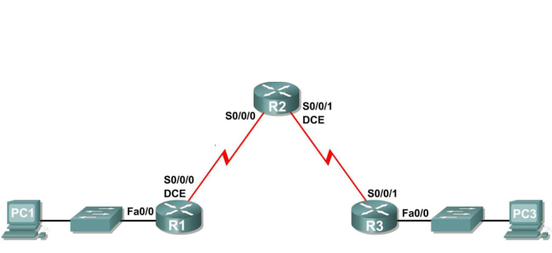

Original IP Address: 10.11.12.0
Original Subnet Mask: 255.255.255.0

- You have been given the above topology diagram and network address information. You have been asked to subnet the address space so that you can have the most number of hosts available as possible for each subnet. Complete the subnetting exercise and fill in the below table.

Subnet | Network Address | First Useable Host | Last Useable Host | Broadcast Address
R1 – Fa0/0 – LAN | 10.11.12.0 | 10.11.12.1 | 10.11.12.62 | 10.11.12.63
R3 – Fa0/0 – LAN | 10.11.12.64 | 10.11.12.65 | 10.11.12.126 | 10.11.12.127
R1–R2 – WAN | 10.11.12.128 | 10.11.12.129 | 10.11.12.190 | 10.11.12.191
R2–R3 – WAN | 10.11.12.192 | 10.11.12.193 | 10.11.12.254 | 10.11.12.255

- It has come to your attention that it was short sighted to not provide for expansion of your network topology. You decide to re-do the subnetting exercise and this time allow for the possibility of having double the amount of current networks in your future network topology. Complete the subnetting exercise and fill in the below table.

Subnet | Network Address | First Useable Host | Last Useable Host | Broadcast Address
R1 – Fa0/0 – LAN | 10.11.12.0 | 10.11.12.1 | 10.11.12.30 | 10.11.12.31
R3 – Fa0/0 – LAN | 10.11.12.32 | 10.11.12.33 | 10.11.12.62 | 10.11.12.63
R1–R2 – WAN | 10.11.12.64 | 10.11.12.65 | 10.11.12.94 | 10.11.12.95
R2–R3 – WAN | 10.11.12.96 | 10.11.12.97 | 10.11.12.126 | 10.11.12.127

- It has been decided that you will never have more than six hosts per subnet (including the router interfaces). You now have a policy of minimising wastage of IP host addresses. Re-do the subnetting exercise and fill in the below table.

Subnet | Network Address | First Useable Host | Last Useable Host | Broadcast Address
R1 – Fa0/0 – LAN | 10.11.12.0 | 10.11.12.1 | 10.11.12.6 | 10.11.12.7
R3 – Fa0/0 – LAN | 10.11.12.8 | 10.11.12.9 | 10.11.12.14 | 10.11.12.15
R1–R2 – WAN | 10.11.12.16 | 10.11.12.17 | 10.11.12.22 | 10.11.12.23
R2–R3 – WAN | 10.11.12.24 | 10.11.12.25 | 10.11.12.30 | 10.11.12.31

